OOJ LAB RECORD BY STHAVIR.G.SOROFF 1BM19CS161

PROGRAMS 1,2,3.

1. Develop a Java program that prints all real solutions to the quadratic equation ax2 +bx+c = 0.Read in a, b, c and use the quadratic formula. If the discriminate b2-4ac is negative, display a message stating

that there are no real solutions.

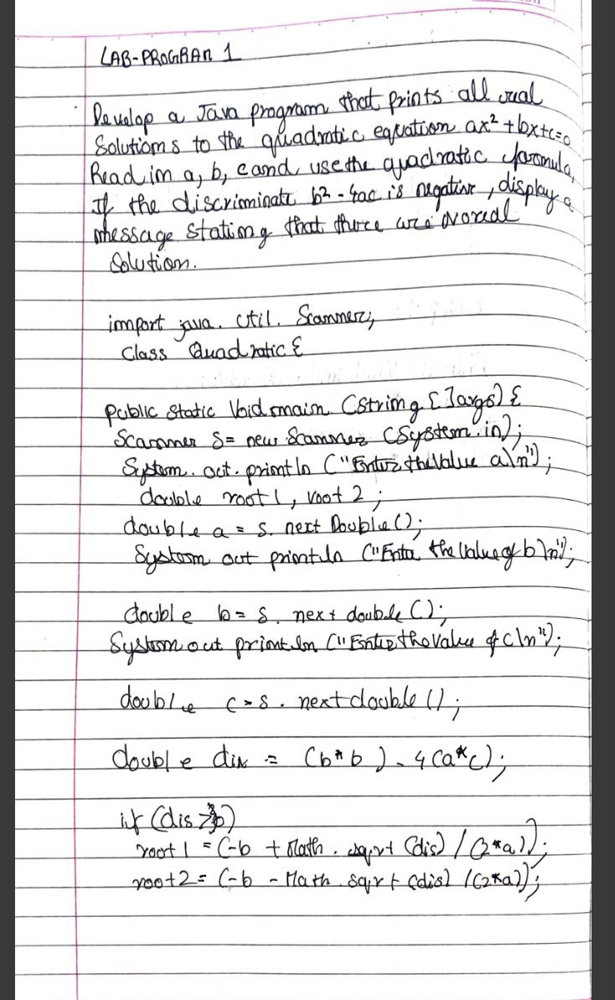

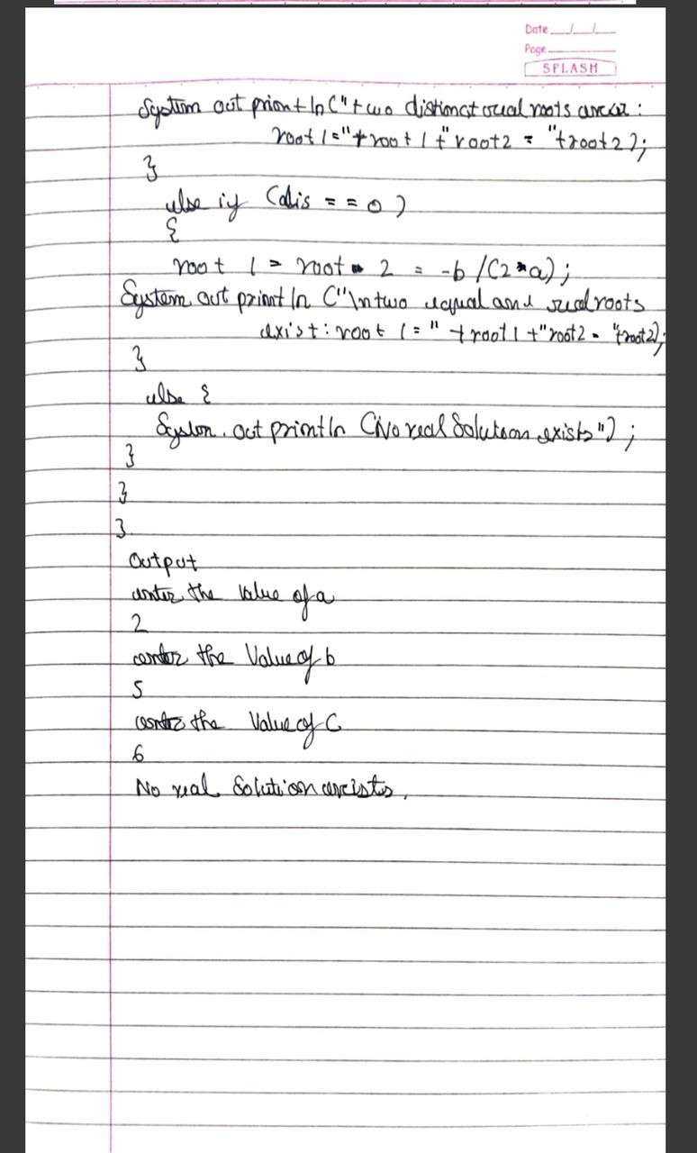

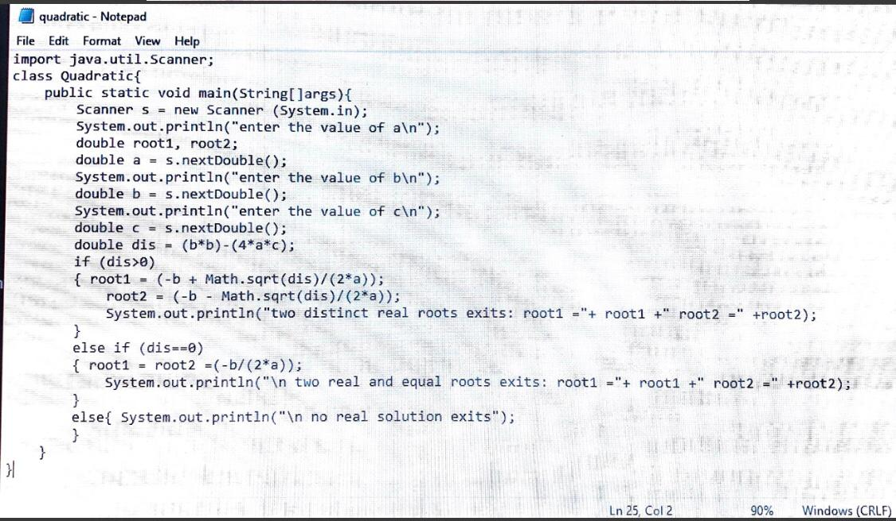

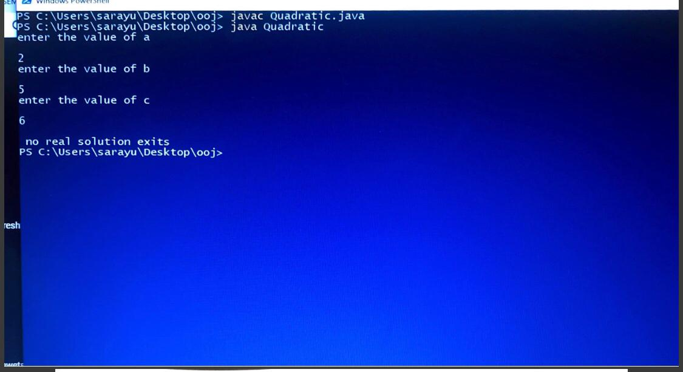

1. Develop a Java program to create a class Student with members usn, name, an array credits and an array marks. Include methods to accept and display details and a method to calculate SGPA of a student.

.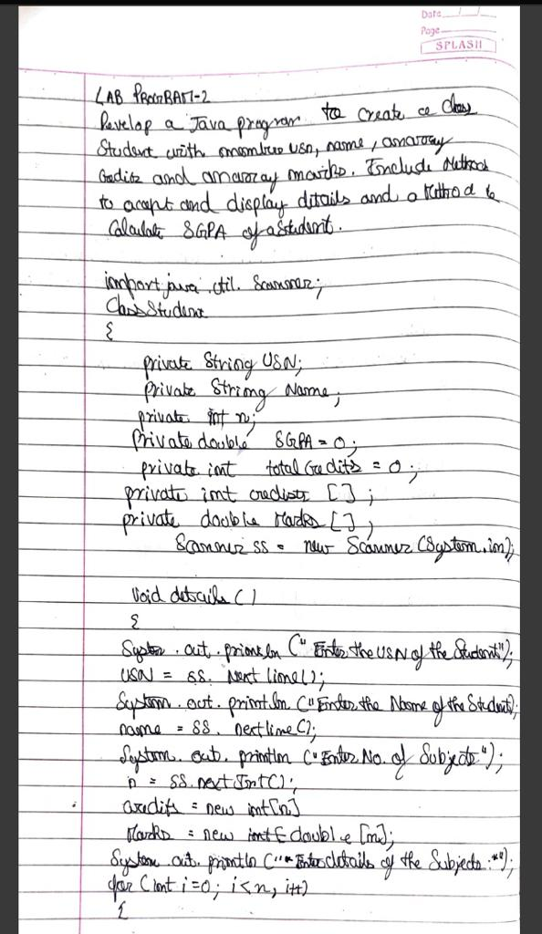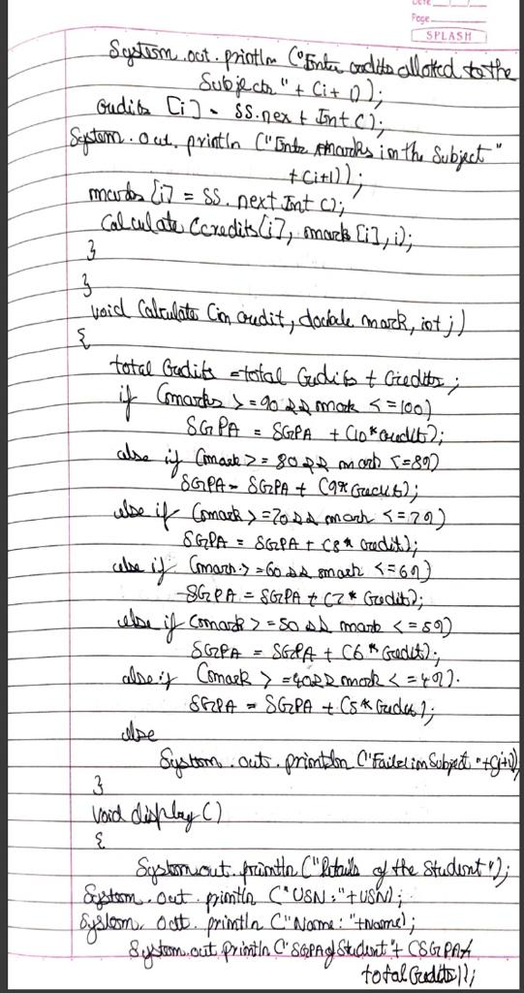

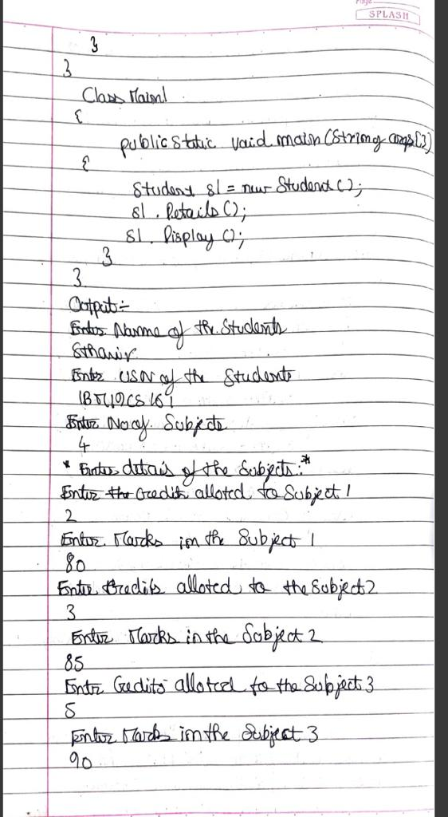

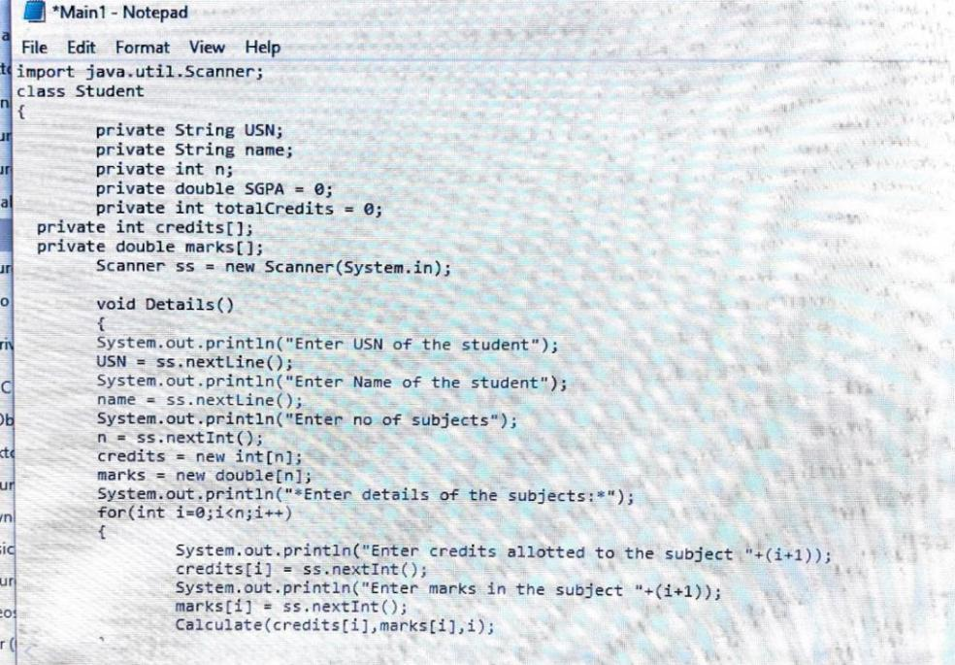

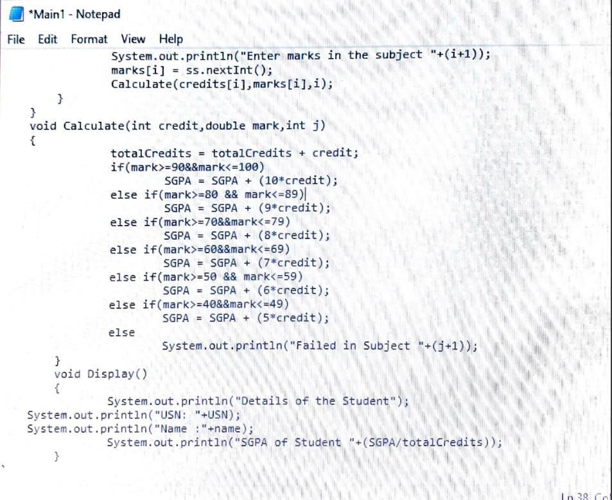

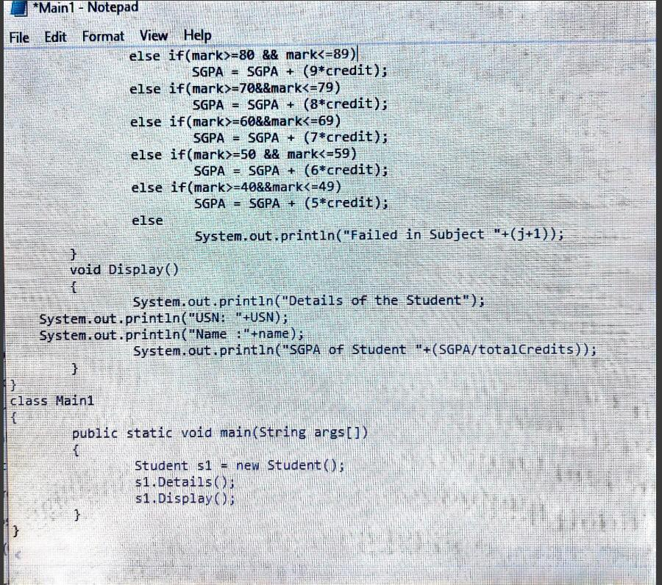

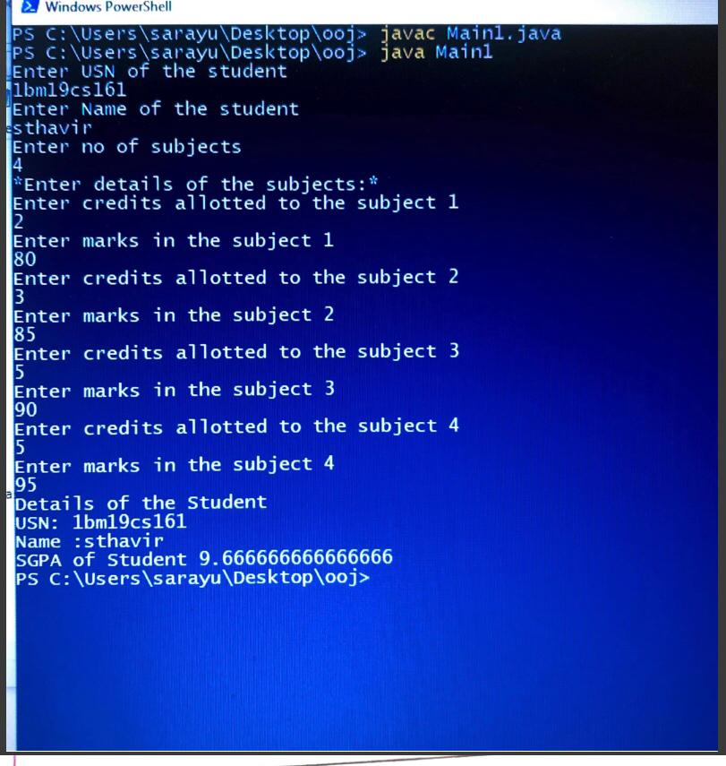

1. Create a class Book which contains four members; name, author, price, num_pages. Include a contructor to set the values for the members. Include methods to set and get the details of the objects. Include a toString() method that could display the complete details of the book. Develop a java program to create n book objects.

